# **SMS Credit Reload Feature – Flowchart & Error Handling**

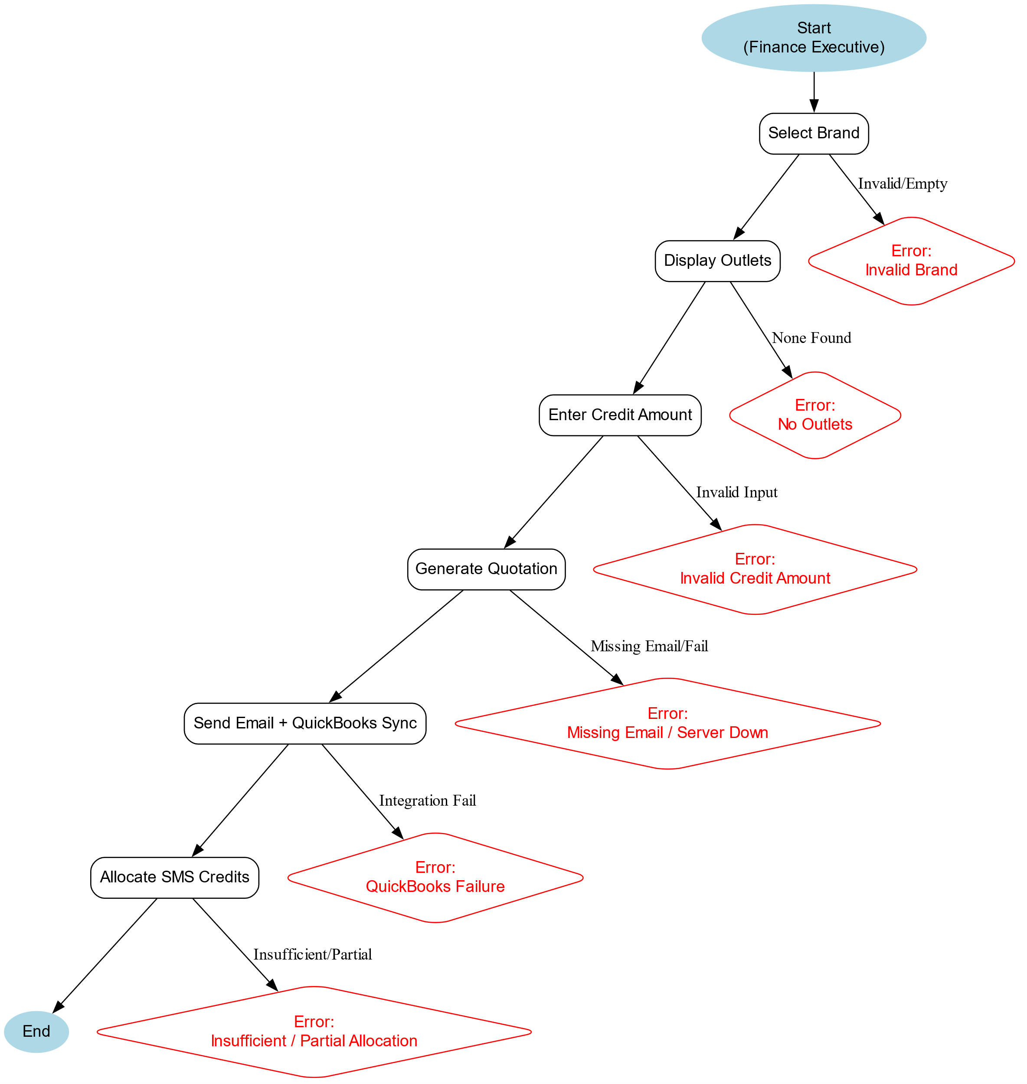

### 

### **Process Workflow**

1. **Brand Selection**
   * Finance executive selects a brand from the dropdown.
   * System validates input and loads outlets.
2. **Outlet Display**
   * All outlets under the selected brand are listed.
   * Includes company name, outlet info, and current credit balance.
3. **Credit Input**
   * User enters top-up amount.
   * System validates against rules (numeric only, minimum RM10, max RM50,000).
4. **Quotation Generation**
   * System generates quotation and sends to client’s registered email.
   * Quotation is logged and synced with QuickBooks.
5. **Credit Allocation**
   * Upon confirmation, SMS credits are allocated to the client’s account.
   * Allocation is outlet-specific if multiple outlets exist.

|  |  |  |
| --- | --- | --- |
| **Category** | **Error Scenario** | **System Response** |
| **Brand Selection** | No brand selected | Error: *“Please select a valid brand to continue.”* |
|  | Invalid/corrupted brand data | Error: *“Unable to load brands – please refresh page.”* |
| **System Connectivity** | Network timeout / DB unavailable | Error: *“Connection timeout – please retry in 5 minutes.”* |
| **Credit Input** | Empty / non-numeric input | Validation: *“Only numbers allowed in credit field.”* |
|  | Below minimum (e.g., RM5) | Error: *“Minimum top-up amount is RM10.”* |
|  | Above maximum (e.g., RM60,000) | Error: *“Maximum limit per transaction is RM50,000.”* |
| **Quotation** | Missing client email | Error: *“Client email not found – please update customer database.”* |
|  | Email server down | Warning: *“Email sending failed – will retry automatically.”* |
| **Integration** | QuickBooks unavailable | Quotation saved but flagged: *“Manual sync required.”* |
| **Credit Allocation** | Insufficient SMS credits in system | Error: *“Insufficient credits available – please contact administrator.”* |
|  | Partial allocation failure (multi-outlet) | Warning: *“Credits allocated to some outlets only – manual review required.”* |
|  | Allocation failure | Rollback transaction with message: *“Allocation failed – transaction reversed.”* |